**Netflix Movies and TV Shows Data Analysis using SQL**

1. Count the number of Movies vs TV Shows

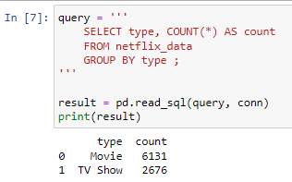

**Objective:** Determine the distribution of content types on Netflix.

1. **Find the Most Common Rating for Movies and TV Shows**

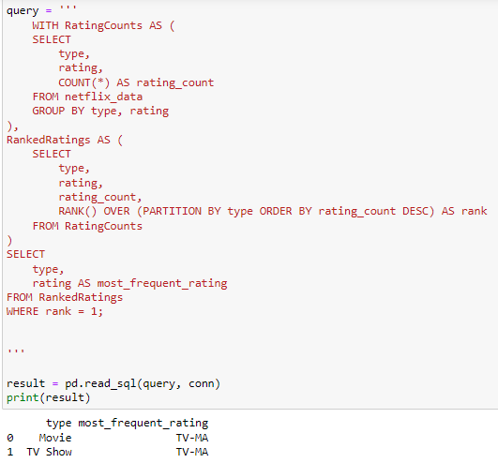

**Objective:** Identify the most frequently occurring rating for each type of content.

1. List all movies released in a specific year (e.g., 2020)

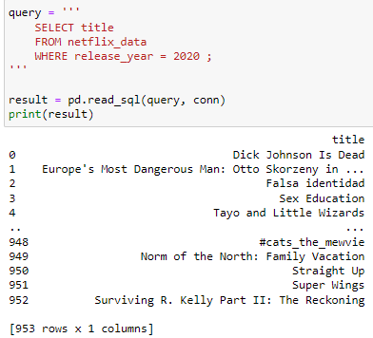

**Objective:** Retrieve all movies released in a specific year.

1. **Find the Top 5 Countries with the Most Content on Netflix**

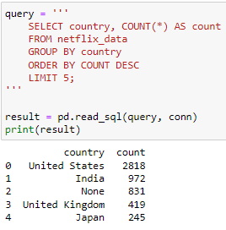

**Objective:** Identify the top 5 countries with the highest number of content items.

1. **Identify the Longest Movie**

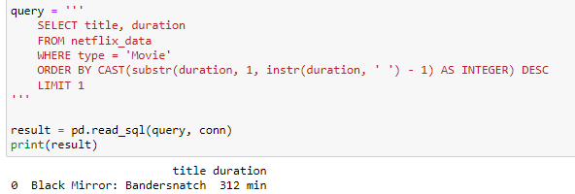

**Objective:** Find the movie with the longest duration.

1. **Find all the movies/TV shows by director 'Rajiv Chilaka**

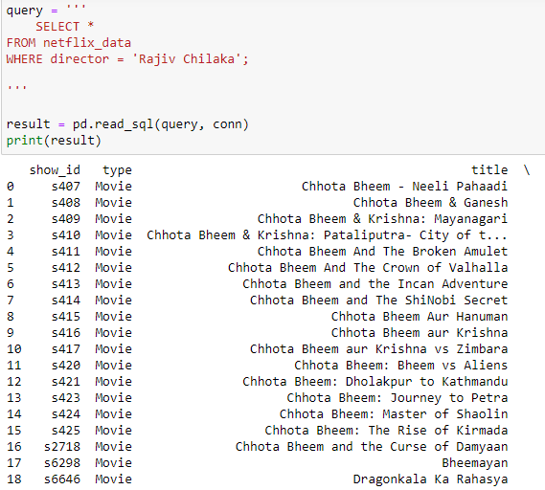

**Objective:** List all content directed by 'Rajiv Chilaka'.

1. **List All TV Shows with More Than 5 Seasons**

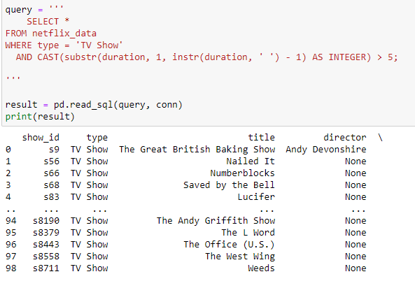

**Objective:** Identify TV shows with more than 5 seasons.

1. **Count the Number of Content Items in Each Genre**

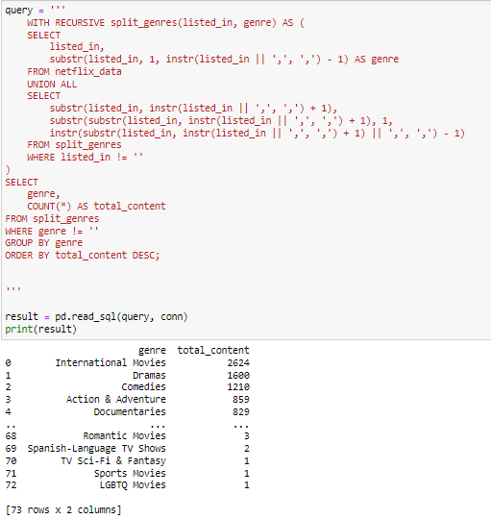

**Objective:** Count the number of content items in each genre.

1. **Find each year and the average numbers of content release in India on netflix.**

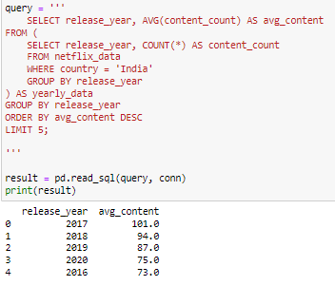

**Objective:** Calculate and rank years by the average number of content releases by India.

1. **Categorize the content based on the presence of the keywords 'kill' and 'violence' in the description field**

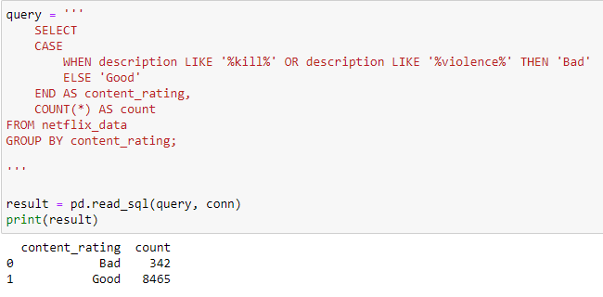

**Objective:** Categorize content as 'Bad' if it contains 'kill' or 'violence' and 'Good' otherwise. Count the number of items in each category.